CSE 5321 SOFTWARE TESTING

FALL 2015

HOMEWORK 3

Submitted by: Sneha Suhas Chitre

Student Id: 1001244953

**Problem 1**

Given problem can be formulated as following:

|  |  |  |  |  |
| --- | --- | --- | --- | --- |
| Sales Volume | Commission Rate | Fee | Status | Gift Card |
| -$0.01 | 0 | -$500.00 | No Sales | No |
| $0.00 | 2.00% | $0.00 | Ordiary Sales | No |
| $24,999.99 | 2.00% | $0.00 | Ordiary Sales | No |
| $25,000.00 | 2.75% | $0.00 | Ordiary Sales | No |
| $99,999.99 | 2.75% | $0.00 | Ordiary Sales | No |
| $100,000.00 | 3.50% | $0.00 | Ordiary Sales | No |
| $200,000.00 | 3.50% | $0.00 | Ordiary Sales | No |
| $200,000.01 | 3.75% | $0.00 | Ordiary Sales | No |
| $400,000.00 | 3.75% | $0.00 | Ordiary Sales | No |
| $400,000.01 | 4.00% | $0.00 | Top Seller Award | Yes |

**Test Case Table** for the above problem is as follows:

|  |  |  |  |  |
| --- | --- | --- | --- | --- |
|  | Input | Expected Output | | |
| Test Case | Sales Volume | Amount Paid | Gift Card | Status |
| 1 | -$0.01 | -$500.00 | No | No Sales |
| 2 | $0.00 | $0.00 | No | Ordiary Sales |
| 3 | $24,999.99 | $499.99 | No | Ordiary Sales |
| 4 | $25,000.00 | $687.50 | No | Ordiary Sales |
| 5 | $99,999.99 | $2,749.99 | No | Ordiary Sales |
| 6 | $100,000.00 | $3,500.00 | No | Ordiary Sales |
| 7 | $200,000.00 | $7,000.00 | No | Ordiary Sales |
| 8 | $200,000.01 | $7,500.00 | No | Ordiary Sales |
| 9 | $400,000.00 | $15,000.00 | No | Ordiary Sales |
| 10 | $400,000.01 | $16,000.00 | Yes | Top Seller Award |

**Decision Table** for above problem is as follows:

|  |  |  |  |  |  |  |
| --- | --- | --- | --- | --- | --- | --- |
| **Conditions/ Rules** | **1** | **2** | **3** | **4** | **5** | **6** |
| Sales Volume < $0 | Y | N | N | N | N | N |
| $0.00 <= Sales Volume <=24999.99 | N | Y | N | N | N | N |
| $25000.00 <= Sales Volume <=99999.99 | N | N | Y | N | N | N |
| $100000.00 <= Sales Volume <=200000.00 | N | N | N | Y | N | N |
| $200000.01 <= Sales Volume <=400000.00 | N | N | N | N | Y | N |
| Sales Volume > $400000.00 | N | N | N | N | N | Y |
| **Actions** |  |  |  |  |  |  |
| Comission Rate : 0.00% | X |  |  |  |  |  |
| Comission Rate : 2.00% |  | X |  |  |  |  |
| Comission Rate : 2.75% |  |  | X |  |  |  |
| Comission Rate : 3.50% |  |  |  | X |  |  |
| Comission Rate : 3.75% |  |  |  |  | X |  |
| Comission Rate : 4.00% |  |  |  |  |  | X |
| Fee $500 | X |  |  |  |  |  |
| No Fee |  | X | X | X | X | X |
| No Sales | X |  |  |  |  |  |
| Ordinary Sales |  | X | X | X | X |  |
| Top Seller Award |  |  |  |  |  | X |
| Gift Card: Yes |  |  |  |  |  | X |
| Gift Card: No | X | X | X | X | X |  |

**JAVA Code** for above problem is given below, as well as src attached.

**Sales_status.java**

**public** **enum** Sales_status {***NO_SALES***,***ORDINARY_SALES***,***TOP_SELLER***};

**EmployeeBonus.java**

**import** javax.swing.*;

**public** **class** EmployeeBonus {

**public** **double** bonus_to_be_paid;

**public** **boolean** gift_card_earned;

**public** **double** gift_card_amount;

**public** **boolean** fee_charged;

**public** **double** fee_amount;

**public** **static** Sales_status *sales_stat*;

**public** **static** **void** main(String args[]){

String SalesVolume;

Double SalesVolumeNew;

SalesVolume= JOptionPane.*showInputDialog*("Enter Sales Volume in currency format($):");

// if (SalesVolume.contains("-"))

SalesVolumeNew = Double.*parseDouble*(SalesVolume);

// calculate_bonus(SalesVolumeNew);

//JOptionPane.showMessageDialog(null, "Amount Paid: ");

}

**public** **void** calculate_bonus(**double** sales_volume) {

**if**(sales_volume < 0 )

{

bonus_to_be_paid = -500.00;

fee_charged=**true**;

fee_amount=500.00;

gift_card_earned = **false**;

gift_card_amount = 0.00;

*sales_stat*= Sales_status.***NO_SALES***;

JOptionPane.*showMessageDialog*(**null**, "Bonus to be Paid: $" +bonus_to_be_paid+"\nSales_Status: "+*sales_stat*+"\nFee Charged: "+fee_charged +"\nFee Amount: $"+fee_amount+"\nGift Card Earned: "+gift_card_earned+"\nGift Card Ampount: $"+gift_card_amount);

//return sales_volume;

}

**else** **if**(sales_volume >= 0.00 && sales_volume <=24999.99 )

{

bonus_to_be_paid = (2.00*sales_volume)/100;

gift_card_earned = **false**;

gift_card_amount = 0.00;

*sales_stat*= Sales_status.***ORDINARY_SALES***;

fee_charged=**false**;

fee_amount=0.00;

System.***out***.println("Bonus to be Paid: $" + bonus_to_be_paid + "\nSales_Status: " + *sales_stat* + "\nFee Charged: " + fee_charged + "\nFee Amount: $" + fee_amount + "\nGift Card Earned: " + gift_card_earned + "\nGift Card Ampount: $" + gift_card_amount);

JOptionPane.*showMessageDialog*(**null**, "Bonus to be Paid: $" +bonus_to_be_paid+"\nSales_Status: "+*sales_stat*+"\nFee Charged: "+fee_charged +"\nFee Amount: $"+fee_amount+"\nGift Card Earned: "+gift_card_earned+"\nGift Card Ampount: $"+gift_card_amount);

}

**else** **if**(sales_volume >= 25000.00 && sales_volume <=99999.99)

{

bonus_to_be_paid = (2.75*sales_volume)/100;

gift_card_earned = **false**;

gift_card_amount = 0.00;

*sales_stat*= Sales_status.***ORDINARY_SALES***;

fee_charged=**false**;

fee_amount=0.00;

JOptionPane.*showMessageDialog*(**null**, "Bonus to be Paid: $" +bonus_to_be_paid+"\nSales_Status: "+*sales_stat*+"\nFee Charged: "+fee_charged +"\nFee Amount: $"+fee_amount+"\nGift Card Earned: "+gift_card_earned+"\nGift Card Ampount: $"+gift_card_amount);

}

**else** **if**(sales_volume >= 100000.00 && sales_volume <=200000.00)

{

bonus_to_be_paid = (3.50*sales_volume)/100;

gift_card_earned = **false**;

gift_card_amount = 0.00;

*sales_stat*= Sales_status.***ORDINARY_SALES***;

fee_charged=**false**;

fee_amount=0.00;

JOptionPane.*showMessageDialog*(**null**, "Bonus to be Paid: $" +bonus_to_be_paid+"\nSales_Status: "+*sales_stat*+"\nFee Charged: "+fee_charged +"\nFee Amount: $"+fee_amount+"\nGift Card Earned: "+gift_card_earned+"\nGift Card Ampount: $"+gift_card_amount);

}

**else** **if**(sales_volume >= 200000.01 && sales_volume <=400000.00)

{

bonus_to_be_paid = (3.75*sales_volume)/100;

gift_card_earned = **false**;

gift_card_amount = 0.00;

*sales_stat*= Sales_status.***ORDINARY_SALES***;

fee_charged=**false**;

fee_amount=0.00;

JOptionPane.*showMessageDialog*(**null**, "Bonus to be Paid: $" +bonus_to_be_paid+"\nSales_Status: "+*sales_stat*+"\nFee Charged: "+fee_charged +"\nFee Amount: $"+fee_amount+"\nGift Card Earned: "+gift_card_earned+"\nGift Card Ampount: $"+gift_card_amount);

}

**else** **if**(sales_volume >= 400000.01)

{

bonus_to_be_paid = (4.00*sales_volume)/100;

gift_card_earned = **true**;

gift_card_amount = 250.00;

*sales_stat*= Sales_status.***TOP_SELLER***;

fee_charged=**false**;

fee_amount=0.00;

JOptionPane.*showMessageDialog*(**null**, "Bonus to be Paid: $" +bonus_to_be_paid+"\nSales_Status: "+*sales_stat*+"\nFee Charged: "+fee_charged +"\nFee Amount: $"+fee_amount+"\nGift Card Earned: "+gift_card_earned+"\nGift Card Ampount: $"+gift_card_amount);

}

}

**public** **boolean** isGift_card_earned(){

**return** gift_card_earned;

}

**public** **double** getBonus_to_be_paid(){

**return** bonus_to_be_paid;

}

**public** Sales_status getSales_stat(){

**return** *sales_stat*;

}

}

**Junit Test Cases and JACOCO coverage snapshots** given as below and src also attached.

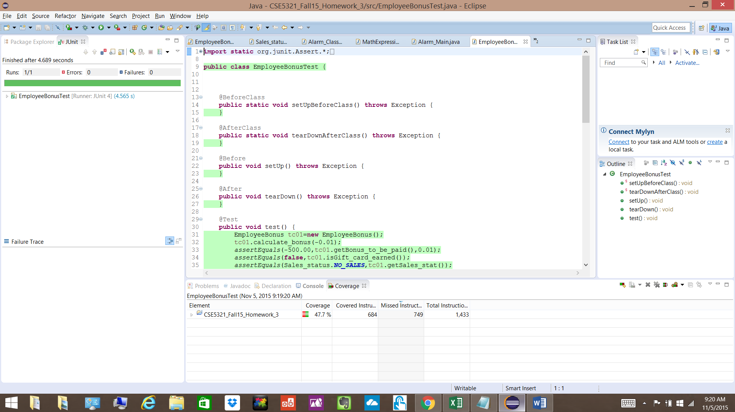

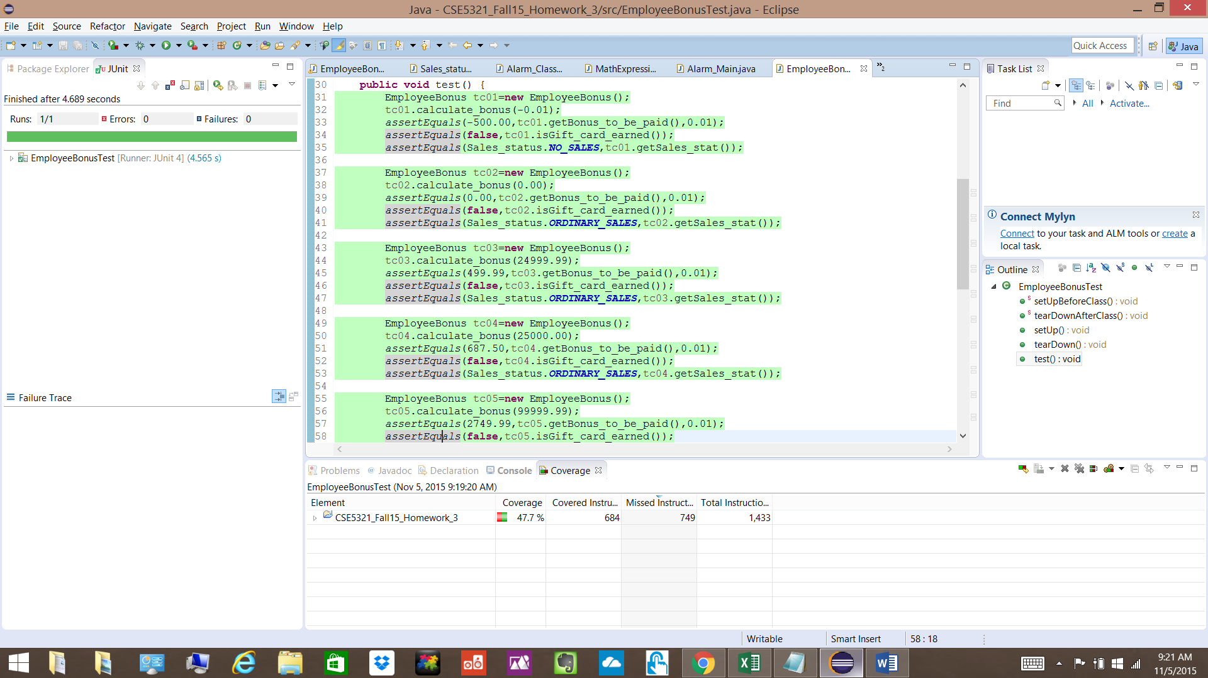

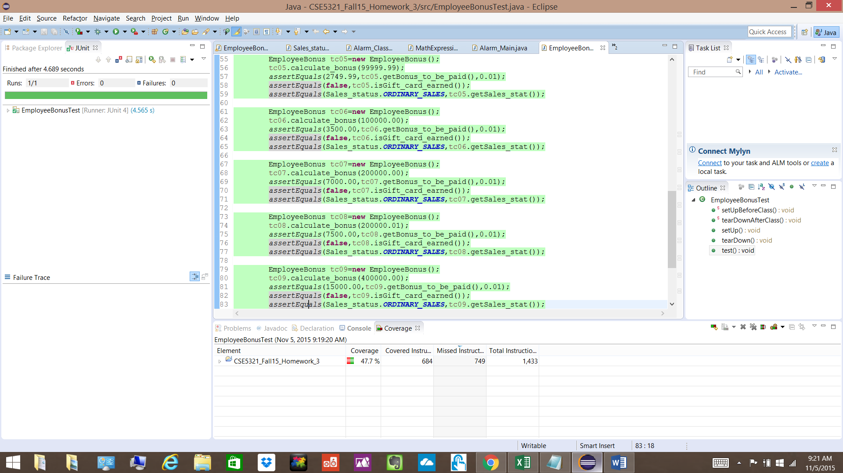

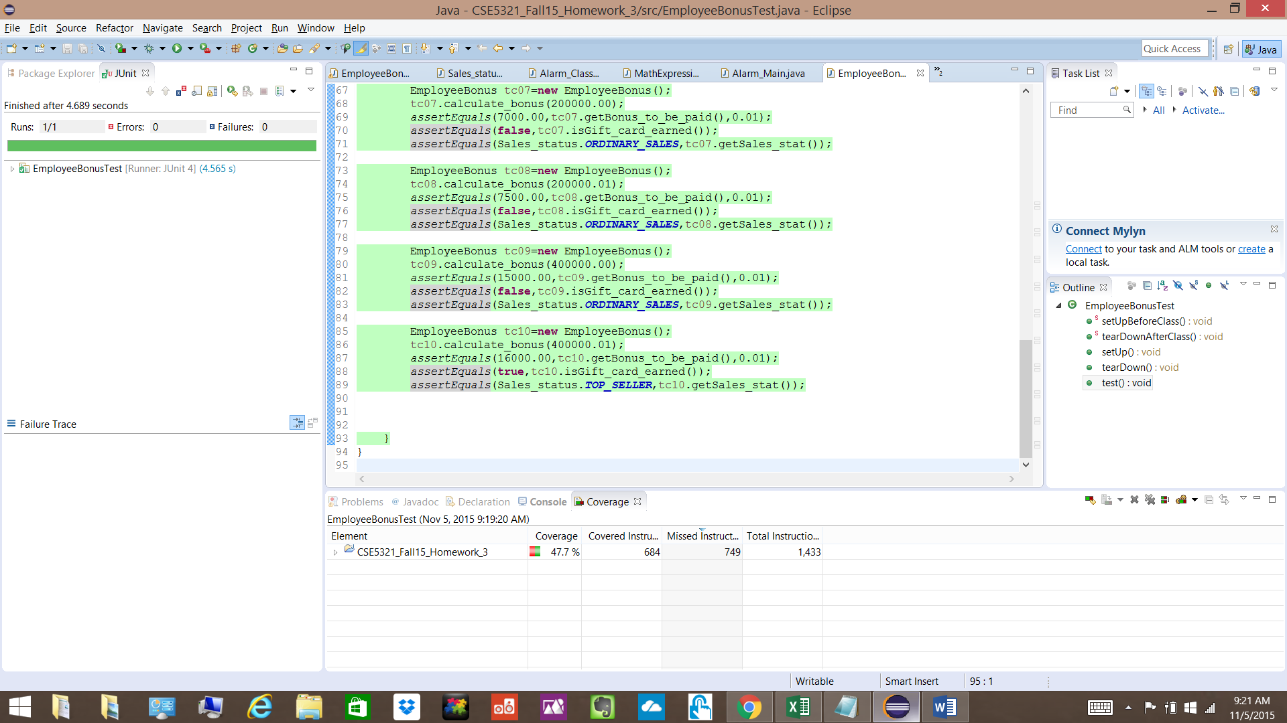

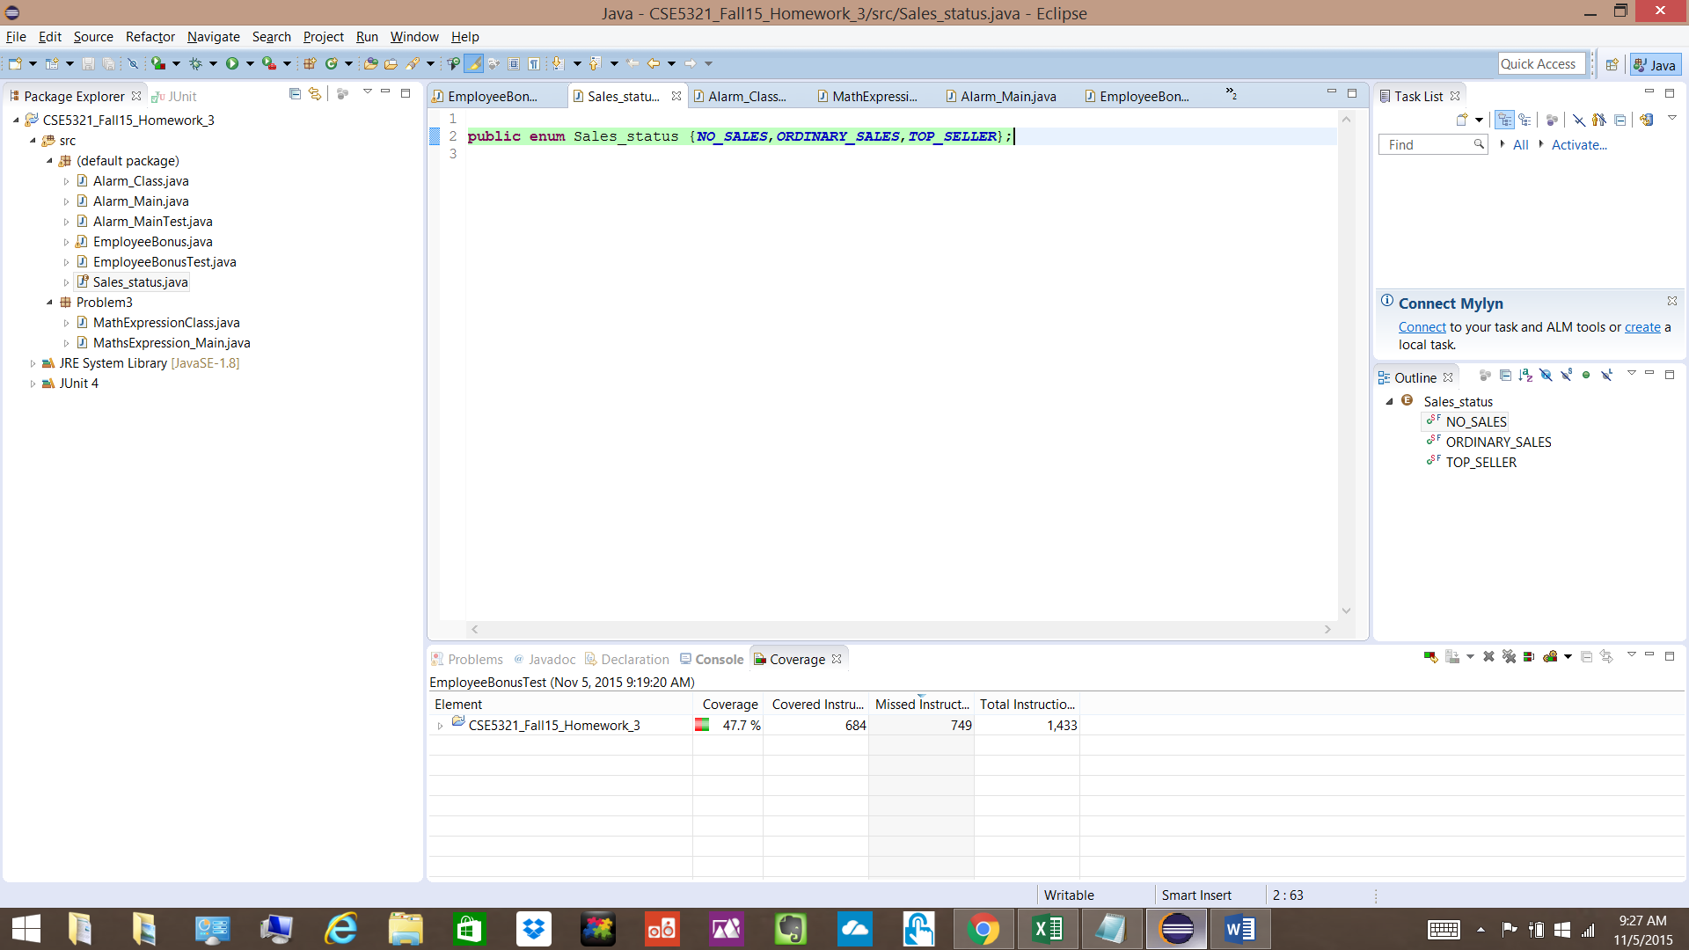

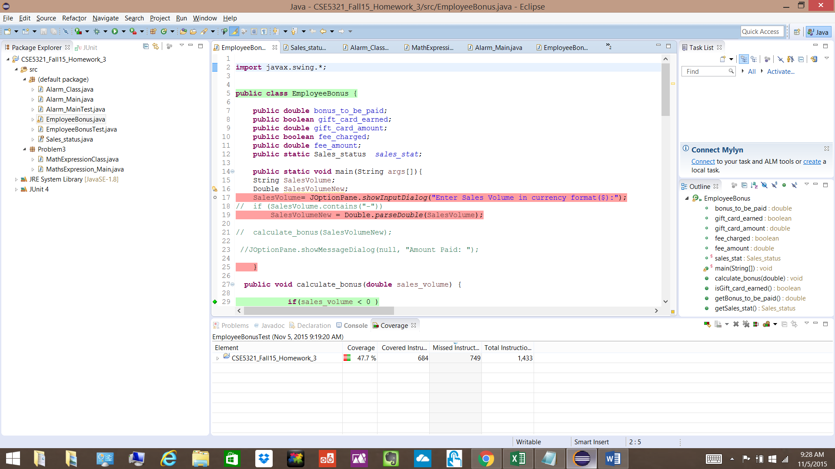

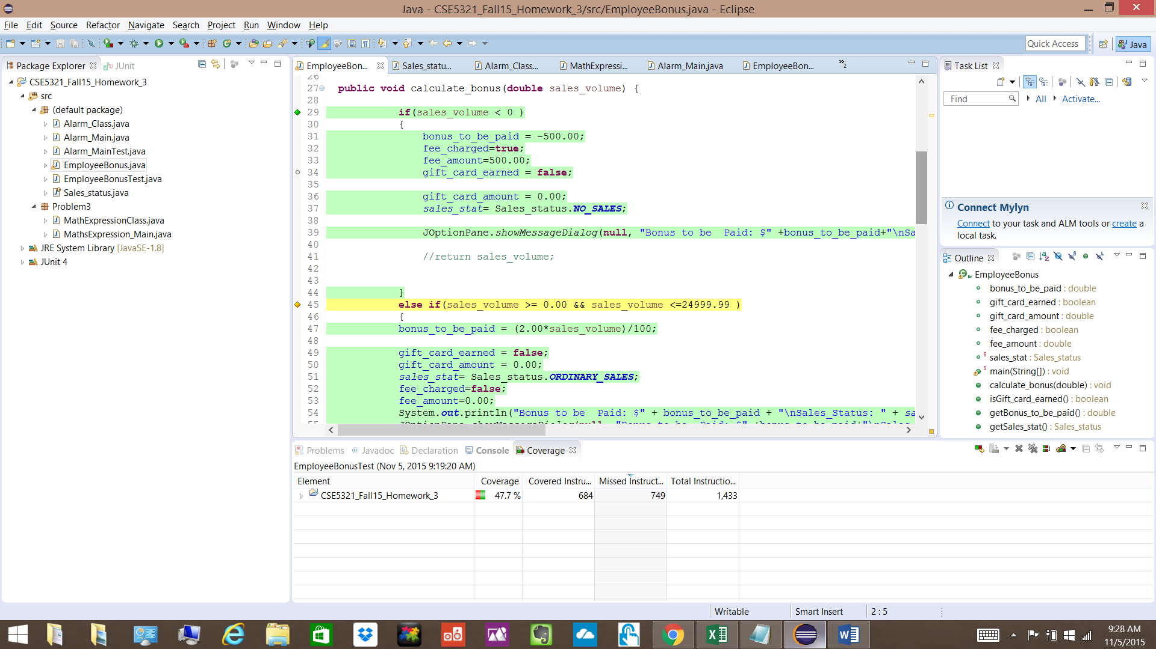

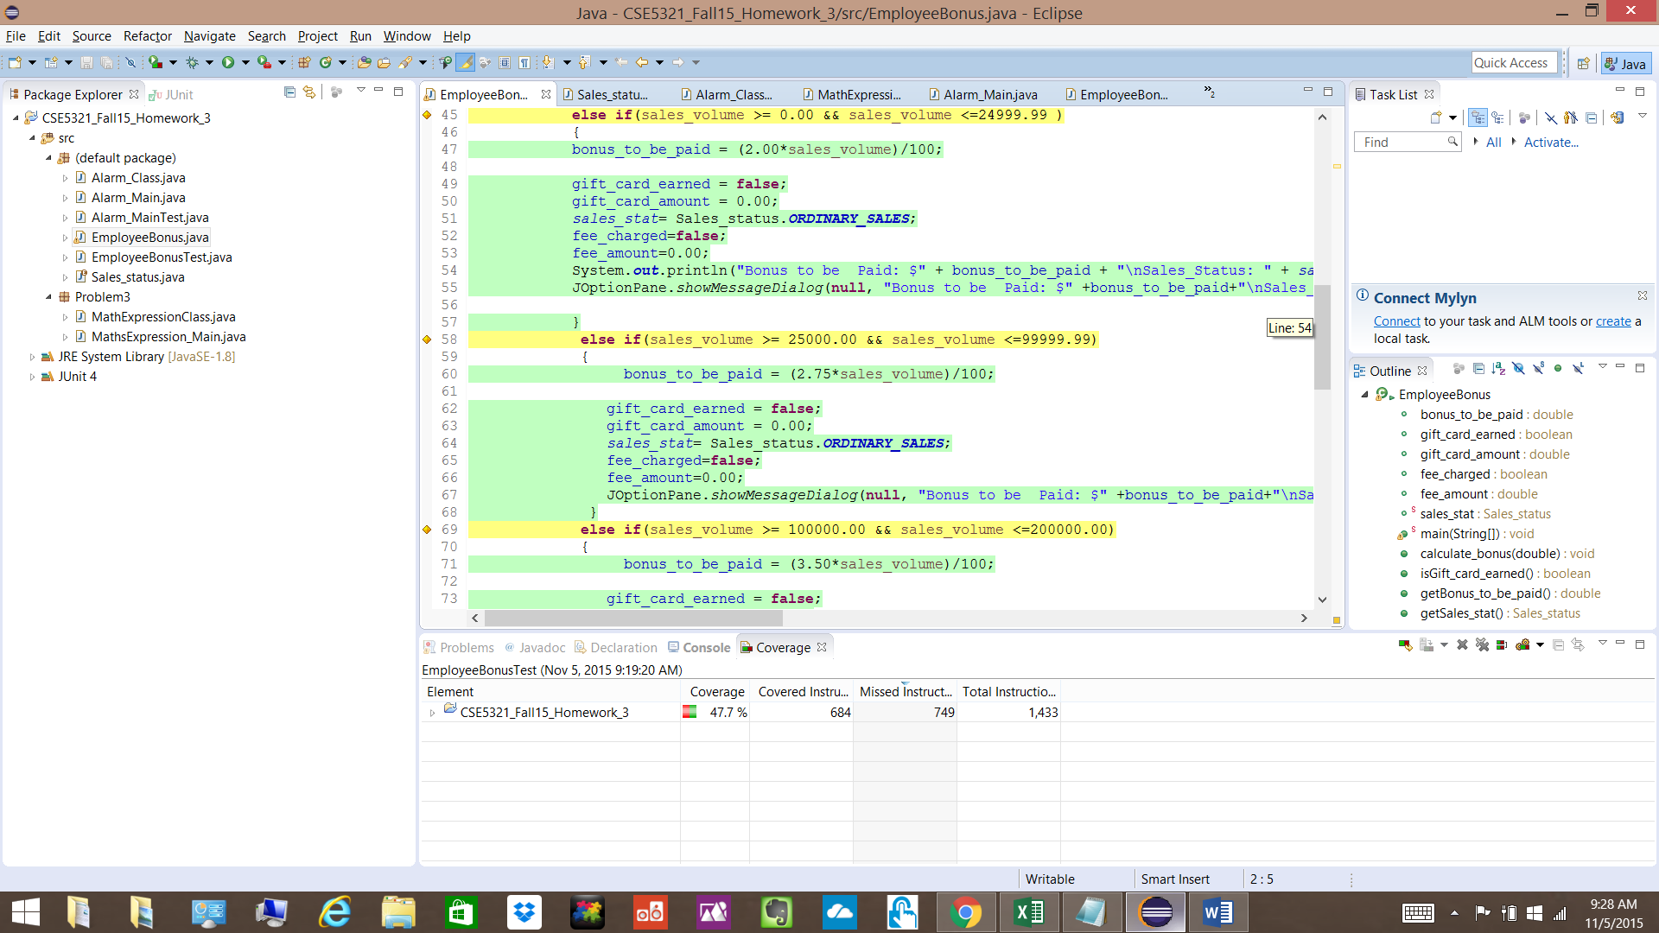

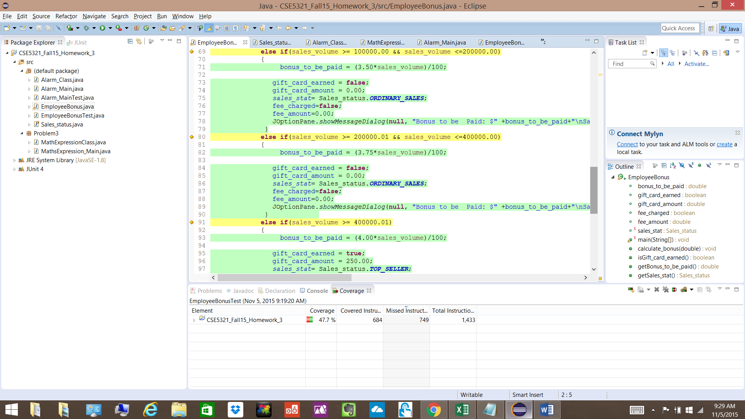

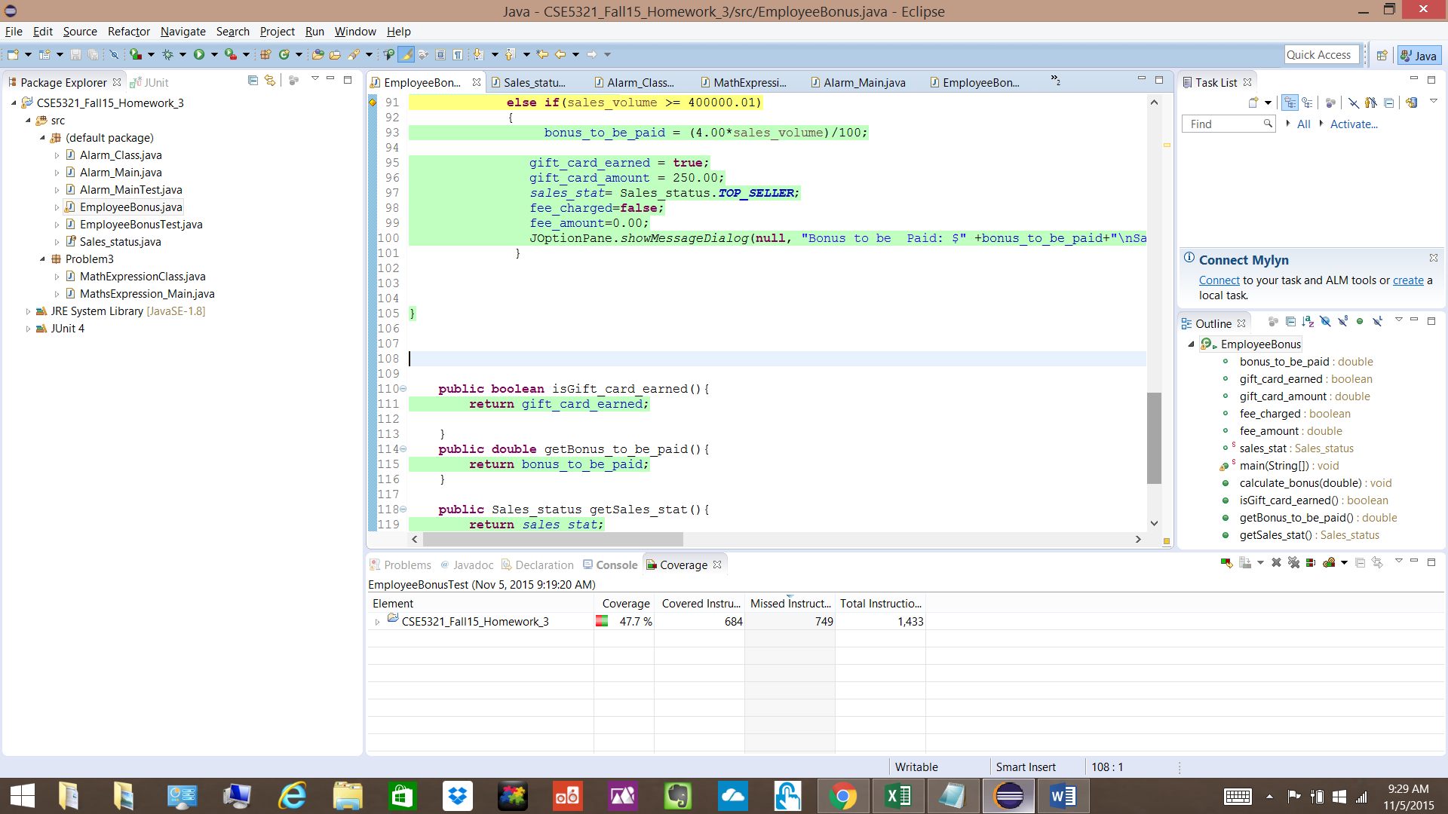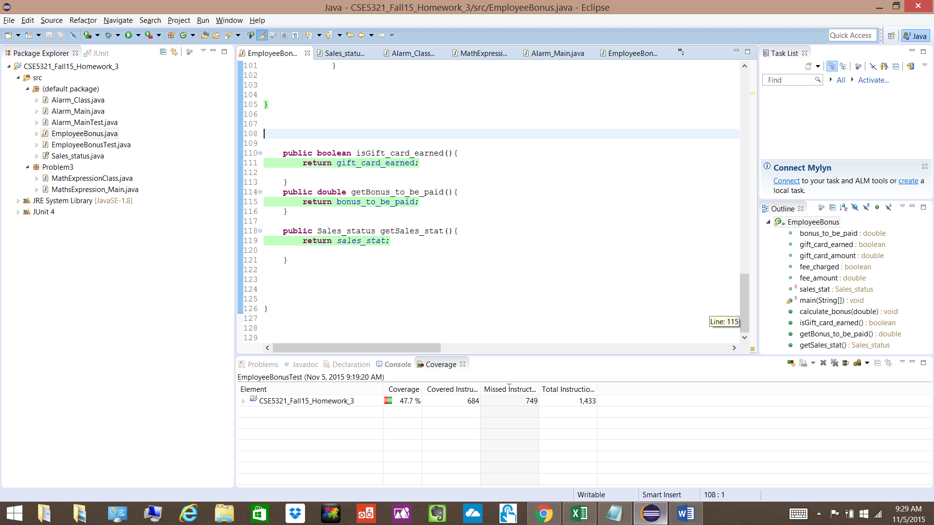

**Problem 2**

Given problem can be formulated as follows:

|  |  |  |  |  |
| --- | --- | --- | --- | --- |
| Tank Reading (Gallons) | Red Light | Yellow Light | Green Light | Chime |
| 500.0 | Off | Off | Off | On |
| 300.0 | Off | Off | Off | On |
| 299.9 | On | Off | Off | On |
| 200.0 | On | Off | Off | On |
| 199.9 | On | On | Off | On |
| 100.0 | On | On | Off | On |
| 99.9 | On | On | On | On |
| 50.1 | On | On | On | On |
| 50.0 | On | On | On | Off |
| 0.0 | On | On | On | Off |

**Test Case Table** for above problem is given as follows:

|  |  |  |  |  |  |
| --- | --- | --- | --- | --- | --- |
|  | Input | Expected Output | | | |
| Test Case | Tank Reading (Gallons) | Red Light | Yellow Light | Green Light | Chime |
| 1 | 500.0 | Off | Off | Off | On |
| 2 | 300.0 | Off | Off | Off | On |
| 3 | 299.9 | On | Off | Off | On |
| 4 | 200.0 | On | Off | Off | On |
| 5 | 199.9 | On | On | Off | On |
| 6 | 100.0 | On | On | Off | On |
| 7 | 99.9 | On | On | On | On |
| 8 | 50.1 | On | On | On | On |
| 9 | 50.0 | On | On | On | Off |
| 10 | 0.0 | On | On | On | Off |

**Decision Table** as below:

|  |  |  |  |  |  |
| --- | --- | --- | --- | --- | --- |
| **Conditions / Rules** | 1 | 2 | 3 | 4 | 5 |
| 500.0 >= Tank Capacity >= 300.0 | Y | N | N | N | N |
| 299.9 >=Tank Capacity >= 200.0 | N | Y | N | N | N |
| 199.9 >= Tank Capacity >= 100.0 | N | N | Y | N | N |
| 99.9 >=Tank Capacity >= 50.1 | N | N | N | Y | N |
| 50.0 >=Tank Capacity >= 0.0 | N | N | N | N | Y |
| **Actions** |  |  |  |  |  |
| Red Light | Off | On | On | On | On |
| Yellow Light | Off | Off | On | On | On |
| Green Light | Off | Off | Off | On | On |
| Chime | On | On | On | On | Off |

**JAVA Code for above problem as below and also attached.**

**Alarm_Main.java**

**import** javax.swing.JOptionPane;

**public** **class** Alarm_Main {

**public** **static** **void** main(String args[]){

Alarm_Class alarm = **new** Alarm_Class();

String gas_tank_reading;

gas_tank_reading= JOptionPane.*showInputDialog*("Enter gas tank reading :");

**double** gas_tank_readingNew = Double.*parseDouble*(gas_tank_reading);

**double** gas_tank_capacity = 500.0;

**if**((gas_tank_readingNew > gas_tank_capacity) || (gas_tank_readingNew < 0.0)) {

JOptionPane.*showMessageDialog*(**null**, "Gas reading should be between 0.0 to 500.0");

} **else** {

alarm.compute_alarms(gas_tank_readingNew);

}

}

}

**Alarm_Class.java**

**import** javax.swing.*;

**public** **class** Alarm_Class {

**private** **boolean** red_light_on=**false**;

**private** **boolean** green_light_on=**false**;

**private** **boolean** yellow_light_on=**false**;

**private** **boolean** chime_on=**false**;

**public** **void** compute_alarms(**double** gas_tank_reading) {

**if** (gas_tank_reading >= 0.0 && gas_tank_reading <= 50.0)

{

red_light_on=**true**;

yellow_light_on=**true**;

green_light_on=**true**;

chime_on=**false**;

JOptionPane.*showMessageDialog*(**null**,"Red_Light On: "+red_light_on+"\nYellow Light On: "+yellow_light_on+"\nGreen Light On: "+green_light_on+"\nChime On:"+chime_on);

}

**else** **if**(gas_tank_reading >= 50.1 && gas_tank_reading <= 99.9)

{

red_light_on=**true**;

yellow_light_on=**true**;

green_light_on=**true**;

chime_on=**true**;

JOptionPane.*showMessageDialog*(**null**,"Red_Light On: "+red_light_on+"\nYellow Light On: "+yellow_light_on+"\nGreen Light On: "+green_light_on+"\nChime On:"+chime_on);

}

**else** **if**(gas_tank_reading >= 100.0 && gas_tank_reading <= 199.9)

{

red_light_on=**true**;

yellow_light_on=**true**;

green_light_on=**false**;

chime_on=**true**;

JOptionPane.*showMessageDialog*(**null**,"Red_Light On: "+red_light_on+"\nYellow Light On: "+yellow_light_on+"\nGreen Light On: "+green_light_on+"\nChime On:"+chime_on);

}

**else** **if**(gas_tank_reading >= 200.0 && gas_tank_reading <= 299.9)

{

red_light_on=**true**;

yellow_light_on=**false**;

green_light_on=**false**;

chime_on=**true**;

JOptionPane.*showMessageDialog*(**null**,"Red_Light On: "+red_light_on+"\nYellow Light On: "+yellow_light_on+"\nGreen Light On: "+green_light_on+"\nChime On:"+chime_on);

}

**else** **if**(gas_tank_reading >= 300.0 && gas_tank_reading <=500.0)

{

red_light_on=**false**;

yellow_light_on=**false**;

green_light_on=**false**;

chime_on=**true**;

JOptionPane.*showMessageDialog*(**null**,"Red_Light On: "+red_light_on+"\nYellow Light On: "+yellow_light_on+"\nGreen Light On: "+green_light_on+"\nChime On:"+chime_on);

}

}

**public** **void** setRed_light_on(**boolean** red_light_on){

**this**.red_light_on=red_light_on;

}

**public** **boolean** isRed_light_on(){

**return** red_light_on;

}

**public** **void** setGreen_light_on(**boolean** green_light_on){

**this**.green_light_on=green_light_on;

}

**public** **boolean** isGreen_light_on(){

**return** green_light_on;

}

**public** **void** setYellow_light_on(**boolean** yellow_light_on){

**this**.yellow_light_on=yellow_light_on;

}

**public** **boolean** isYellow_light_on(){

**return** yellow_light_on;

}

**public** **void** setChime_on(**boolean** chime_on){

**this**.chime_on=chime_on;

}

**public** **boolean** isChime_on(){

**return** chime_on;

}

}

**Junit code and JACOCO coverage analysis snapshots as given below:**

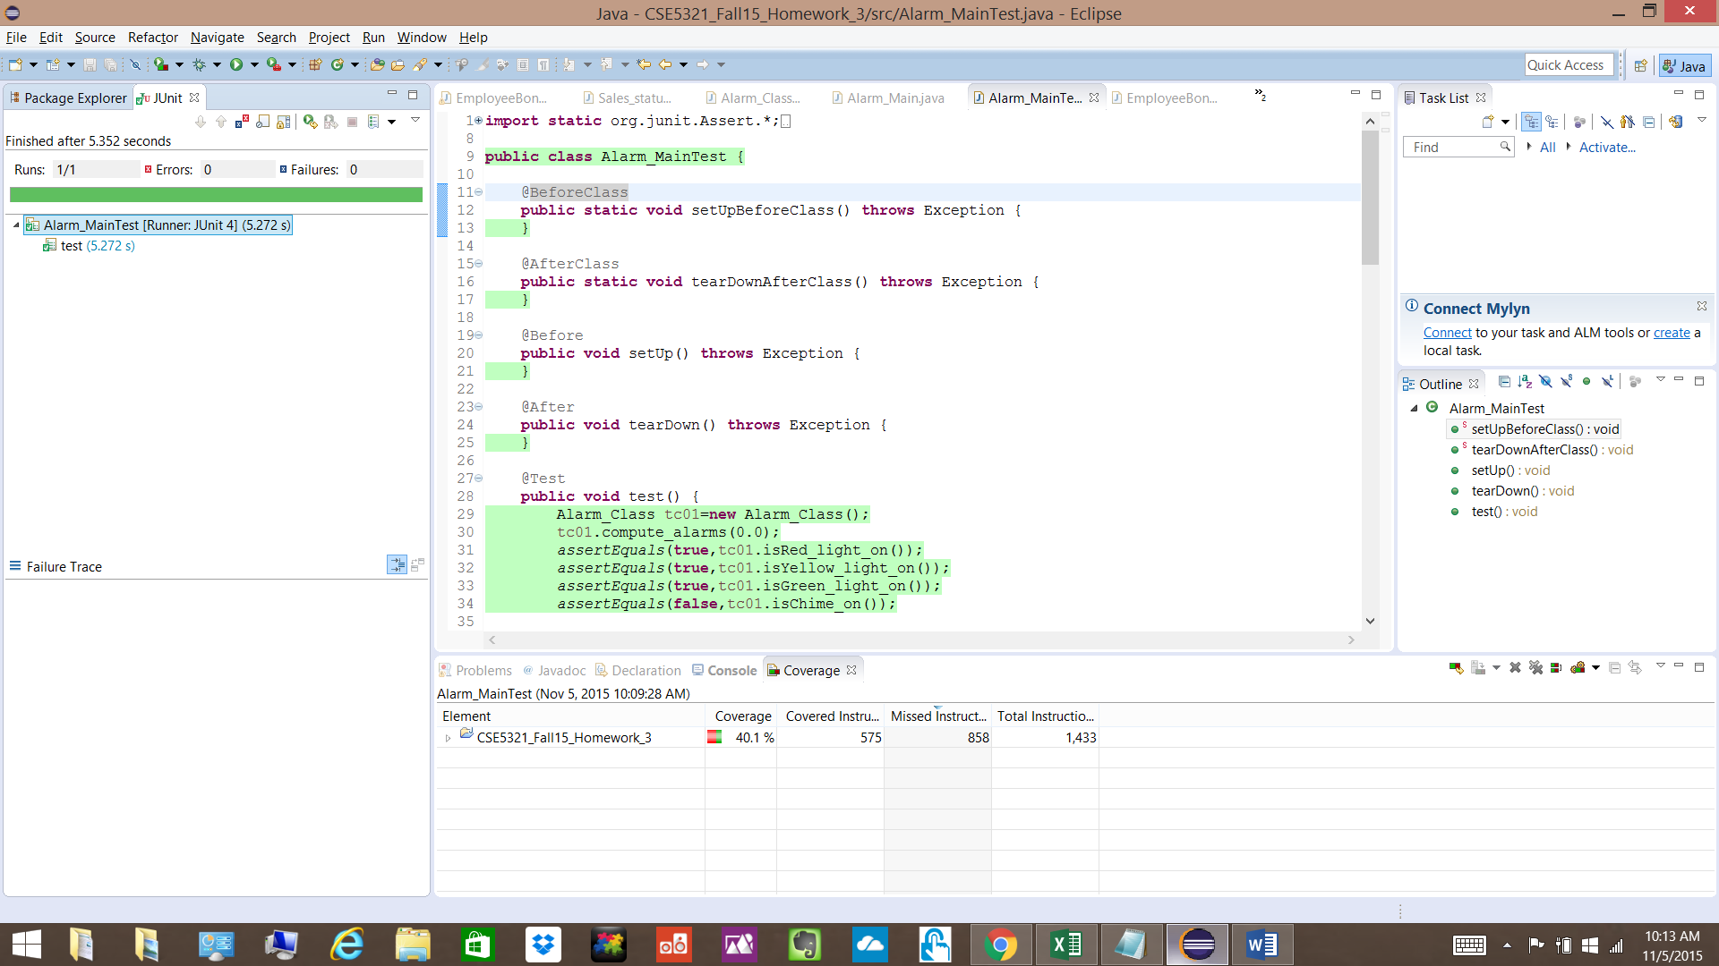

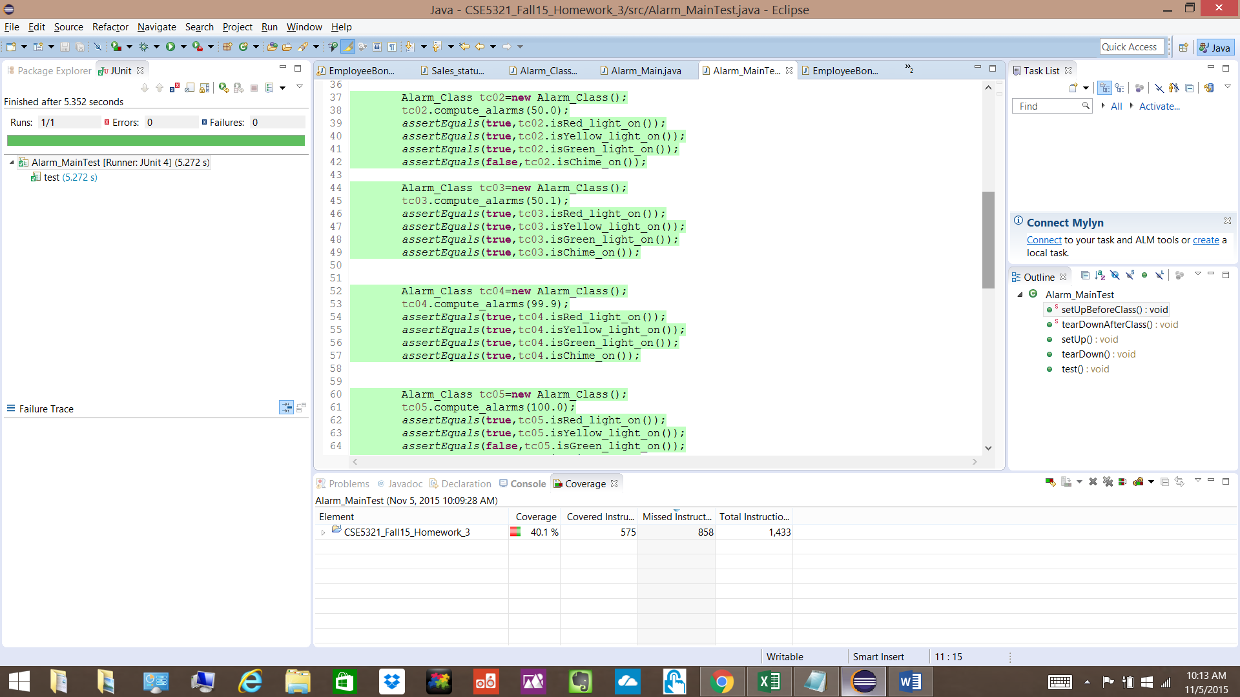

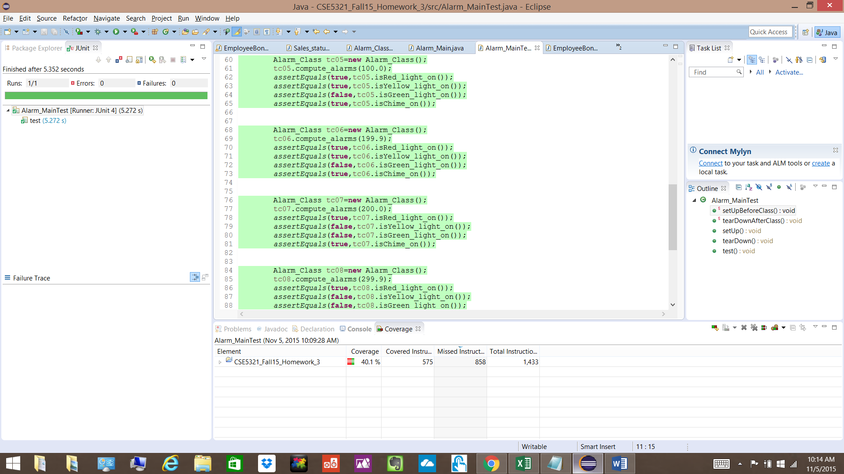

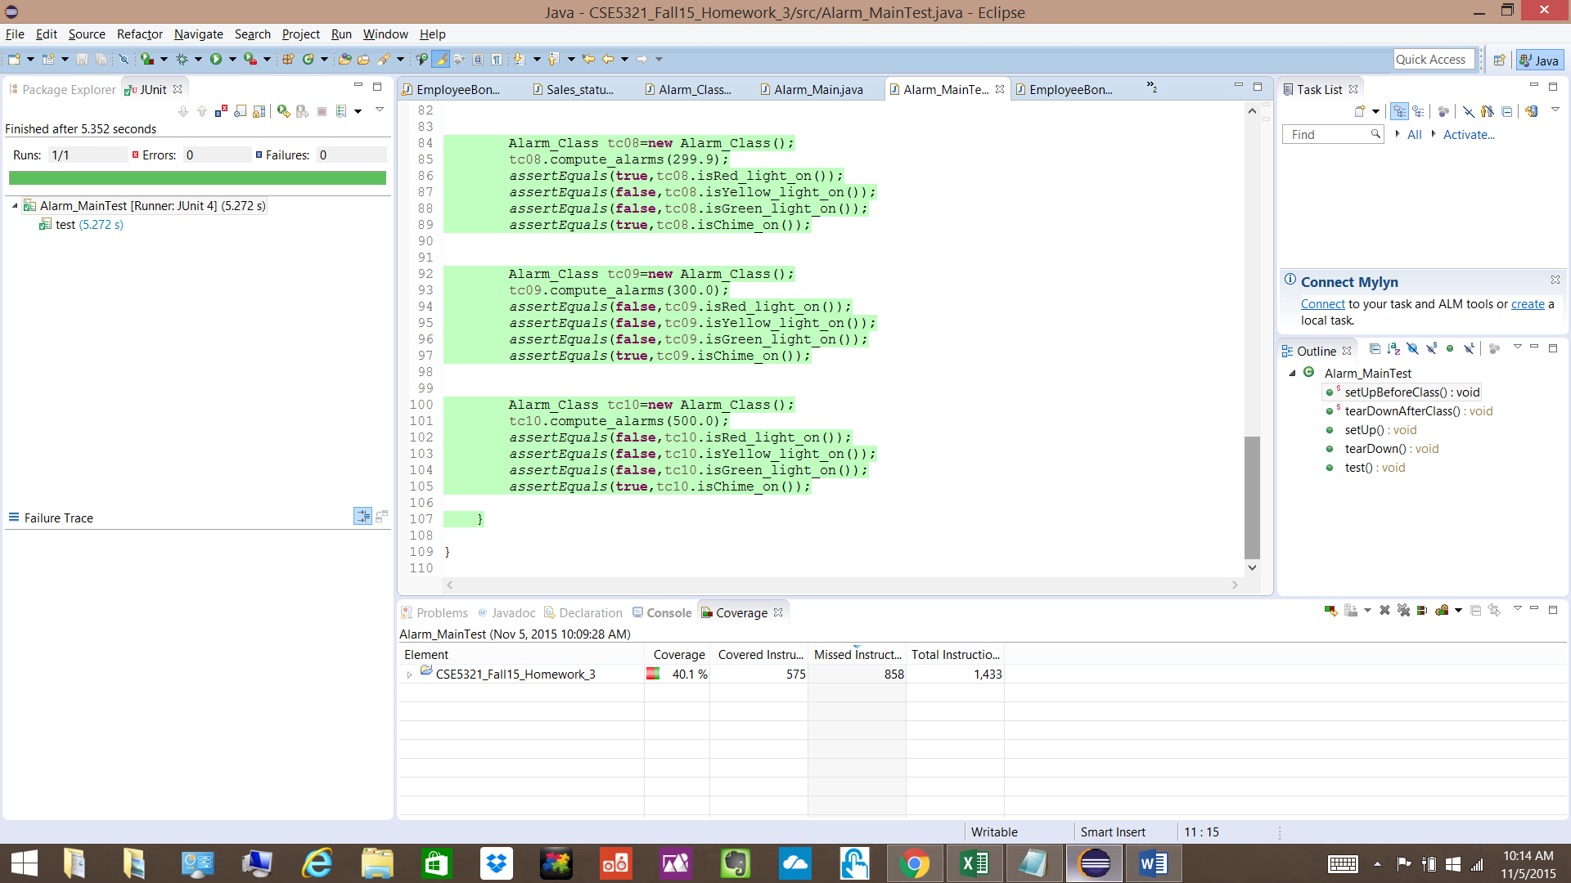

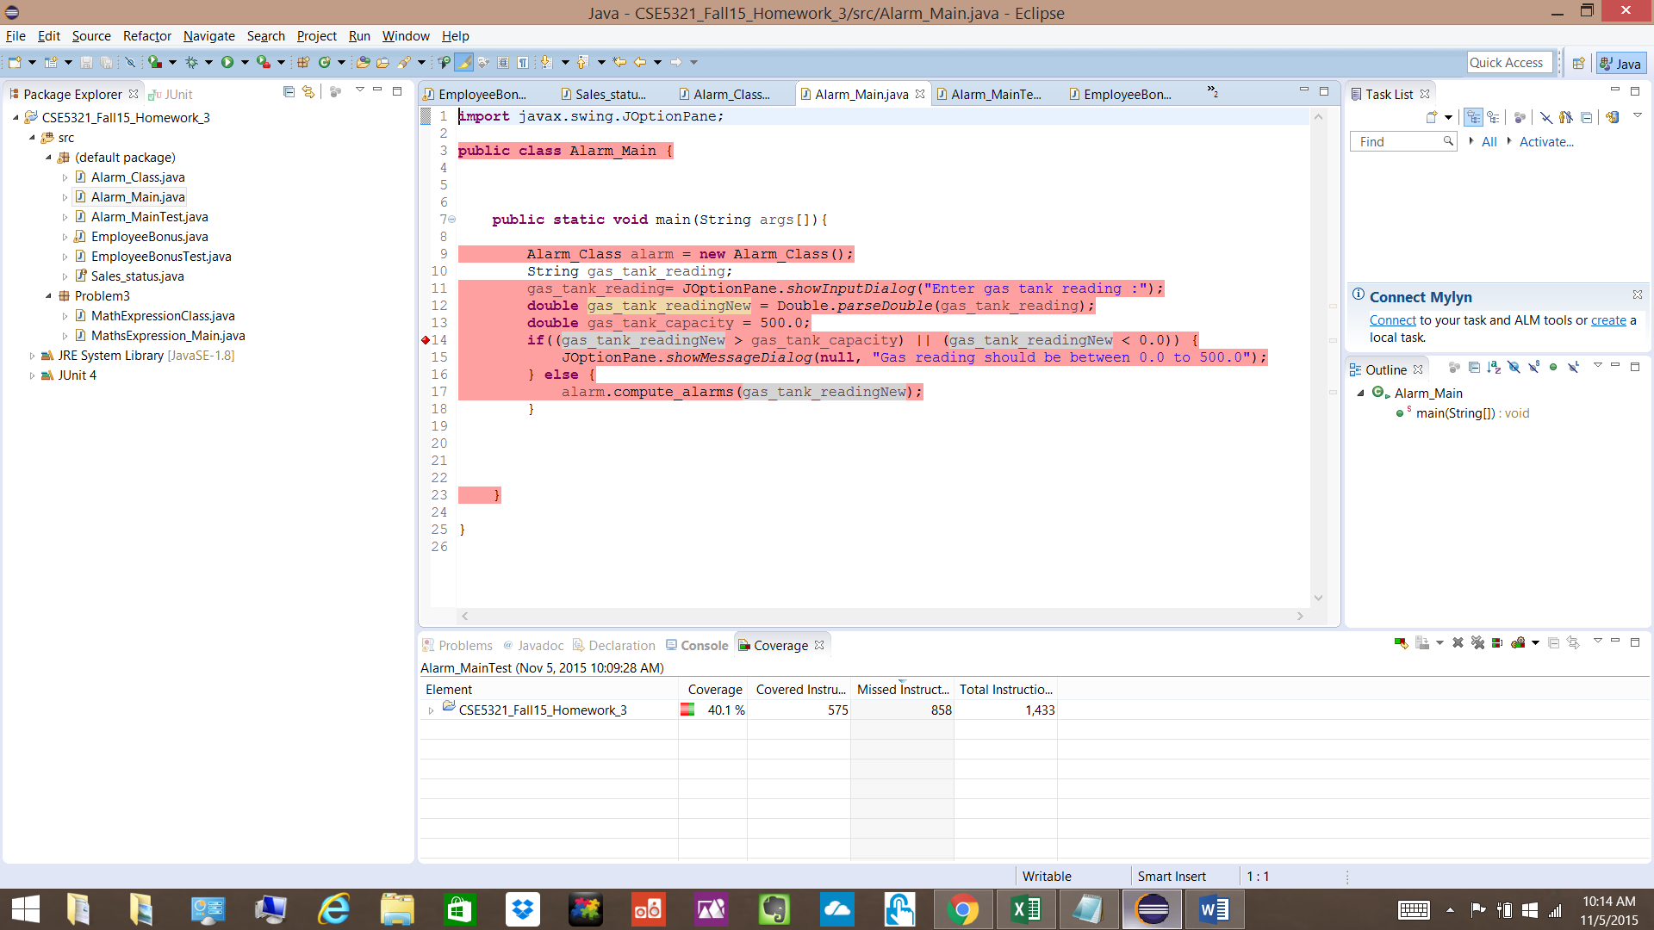

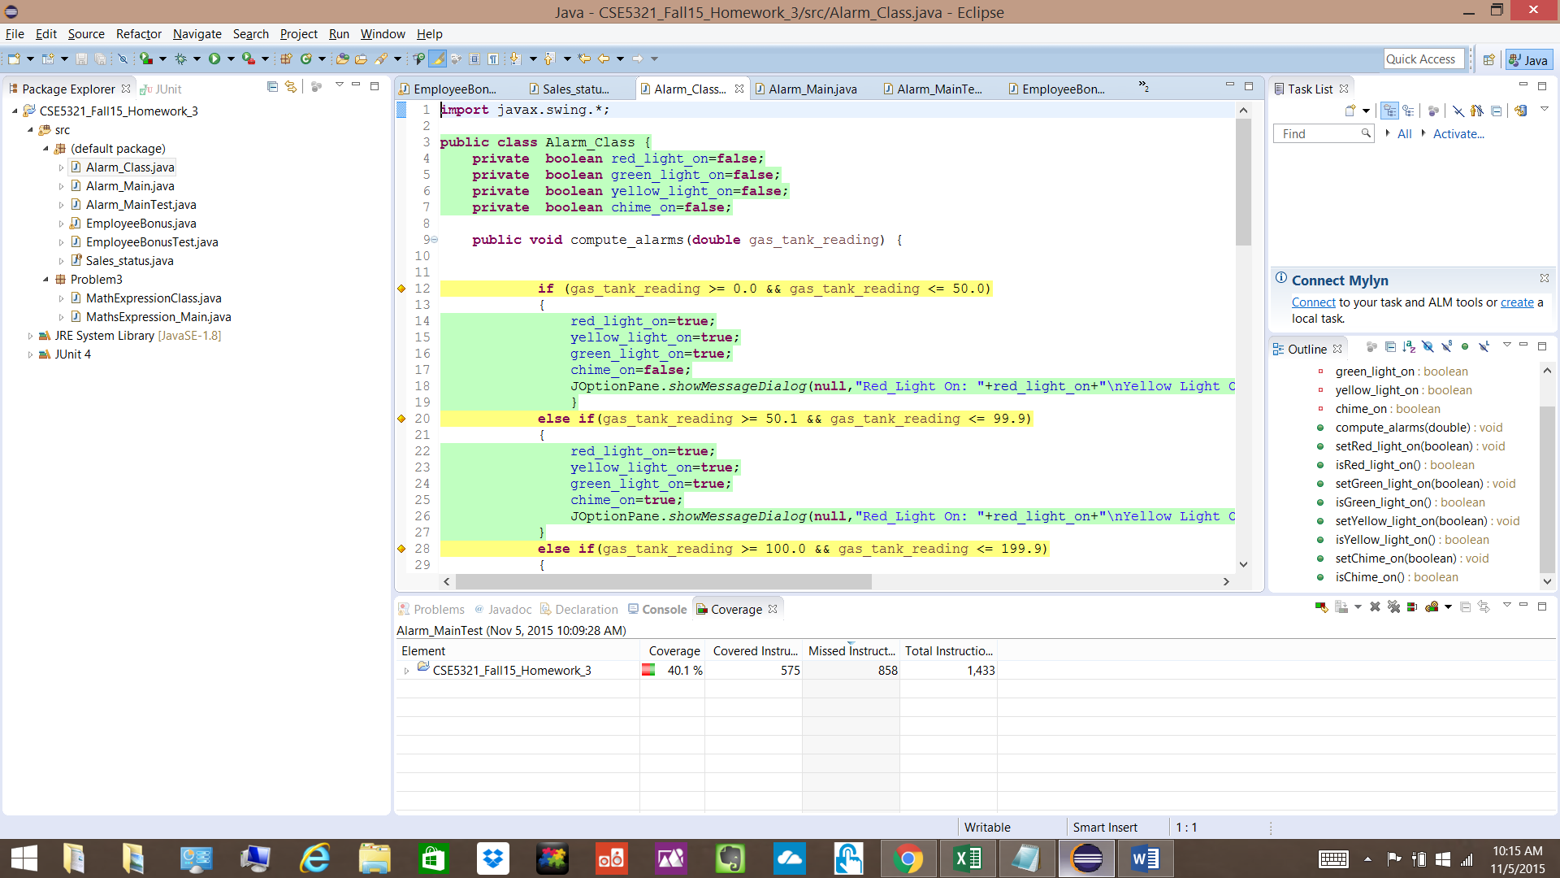

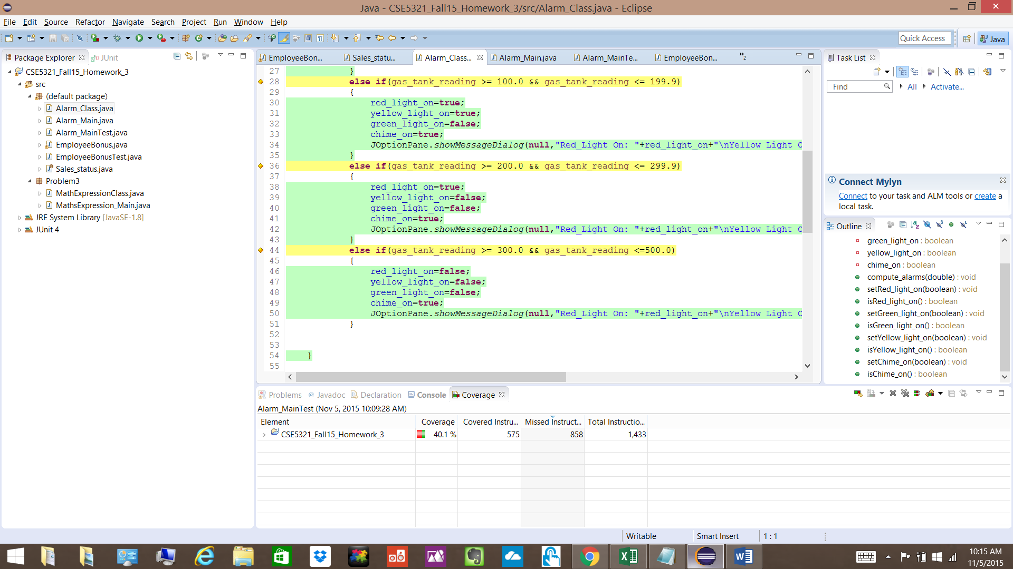

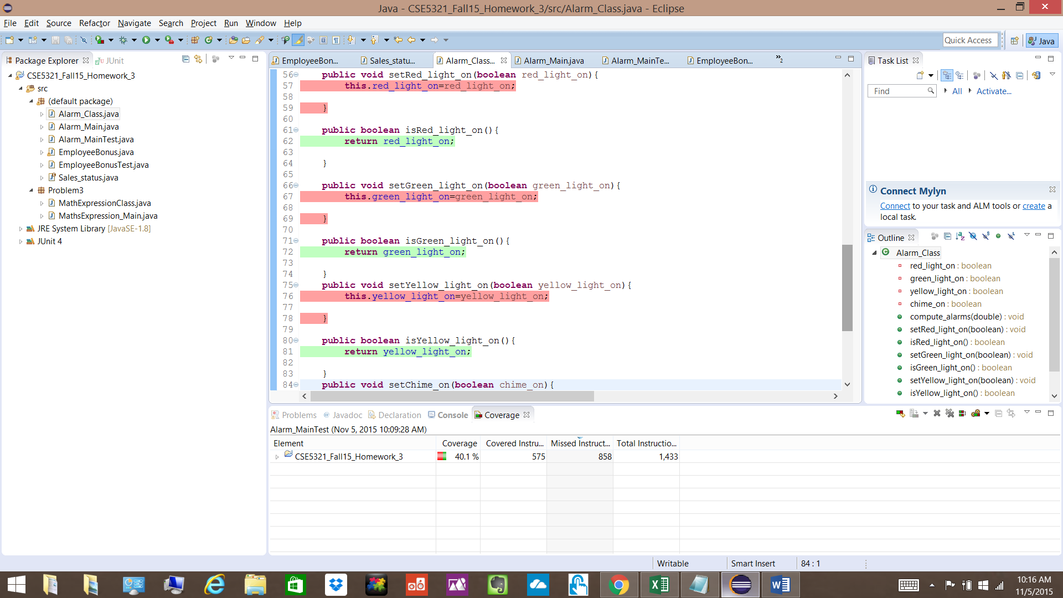

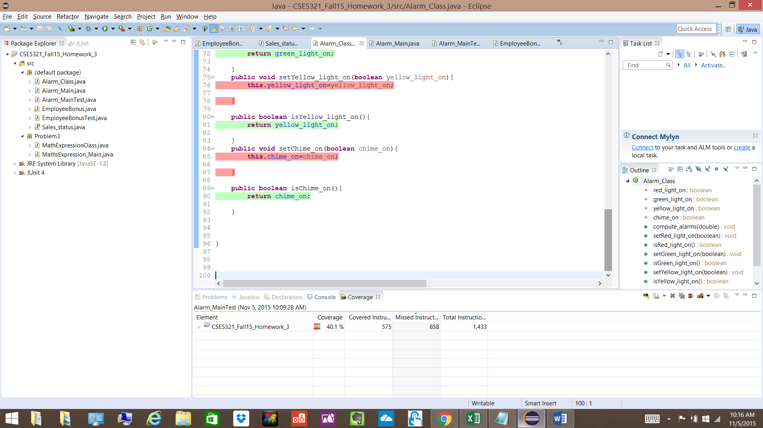

**Problem 3**

MathExpression Class Code

**MathsExpression_Main.java**

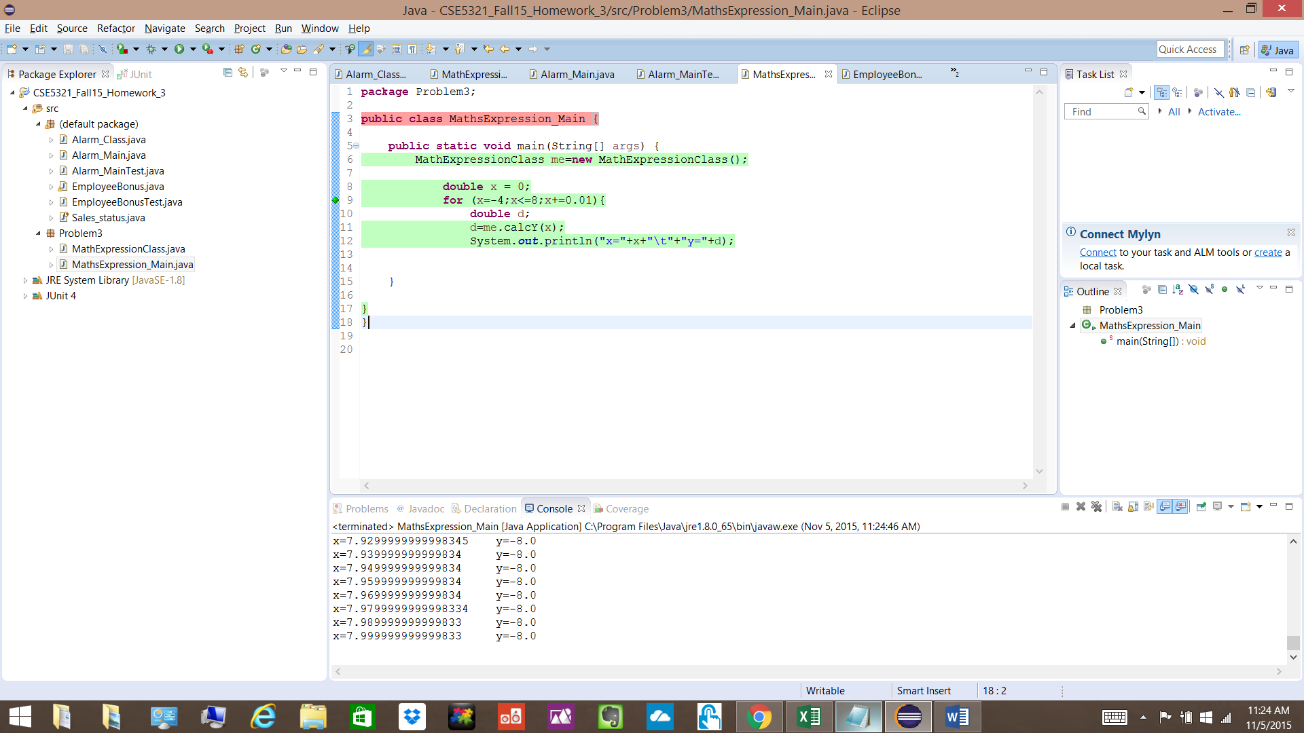

**MathExpressionClass.java**

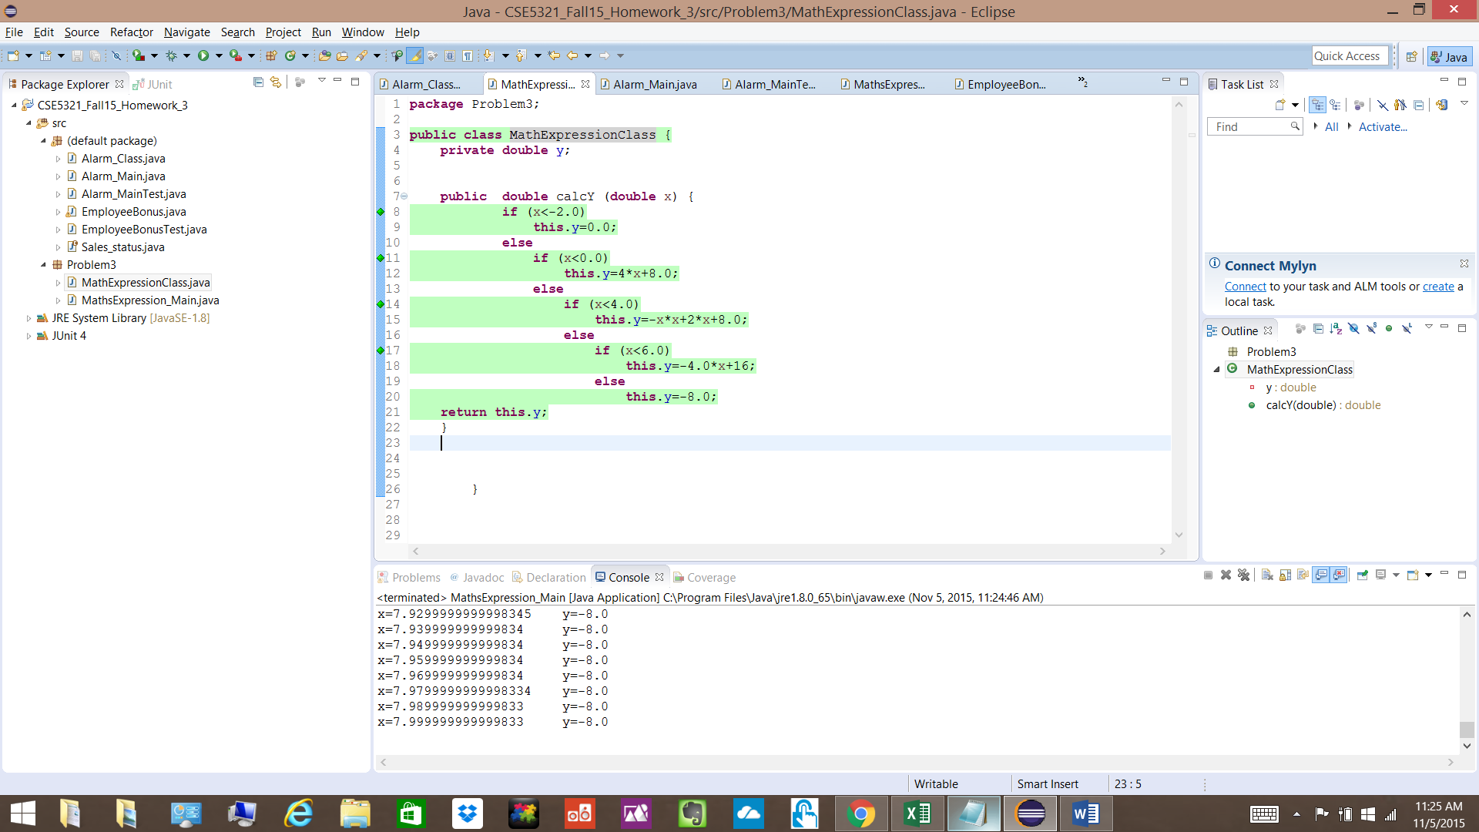

**Output of this code ,the plot, CFG and Test Case Table is attached in the Excel Sheet “HW3_Problem3.xlsx”**